**ECE 9021 Introduction to Digital Image Processing**

Assignment #3

Assignment Group #16

1.(a) **In your report, include a printout of the levelled image (i.e., image with background removed). What did you estimate the coefficients *ai*, *i* = 0, 1…,5, to be? Would you expect these to be identical to what other groups found? Explain your answer.**

[im2, a] =level(‘rice.png’);

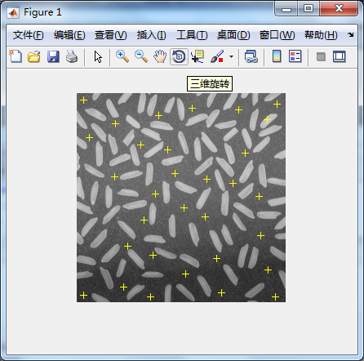

I chose 30 points in rice.png, and get values of a.

a =

93.2425

0.0655

0.2581

0.0002

-0.0017

-0.0006

No，because different groups select different number and different points. Different points cause different values of x,y in equation. When matlab calculates the equation, there will be different coefficients ai.

Imshow(im2) %get the levelled image

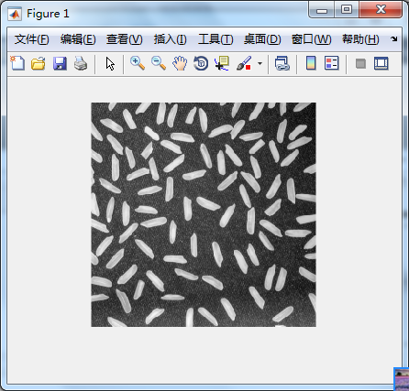

(b) **Using the ‘plot’ command, plot a vertical profile through column 50 of the original  
unlevelled image as a dashed curve. On the same axis, plot a vertical profile through column 50 of the levelled image as a solid curve. You may need to use the help facility in MATLAB to learn more about the plot command, including how to specify line types (dashed or solid) and how to plot on the same axis. Include this plot in your report, and explain whether or not the function level is working correctly.**

Command of making plot:

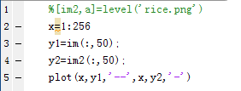

Dashed curve is unlevelled image. Solid curve is levelled image.

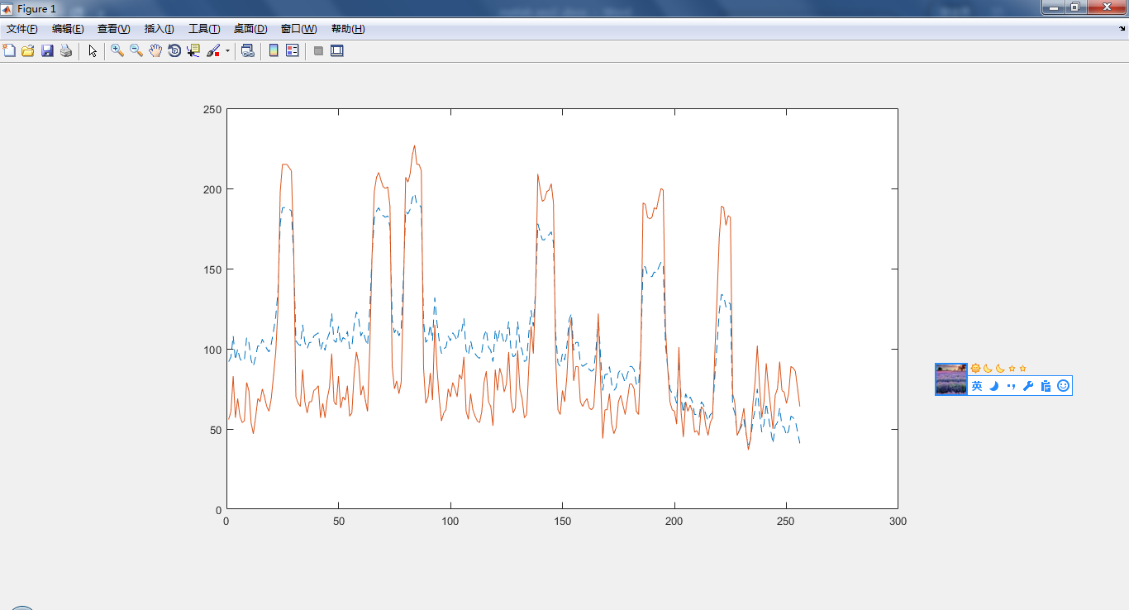

It is obviously that the function level is working correctly. Function level is going to remove the background. From the plot, in the same position in the background, the solid curve is much lower than the dashed curve which means that the color in the levelled image is much darker than the same position in the unlevelled image.

2.(b) **In your report, include a plot of the original image and the points automatically  
selected by your function. Also include a plot of the levelled image. What values of *M* and *N* did you use? Explain your rationale for using the particular values of *M* and *N*.**

[im2,a]=autolevel_16('rice.png');

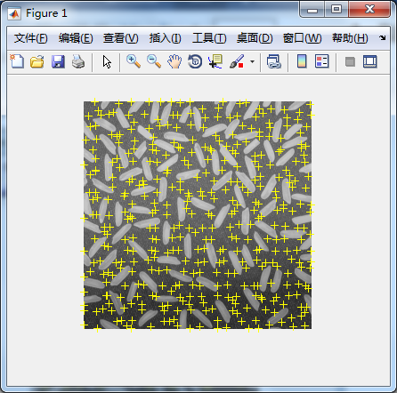

imshow(im2)

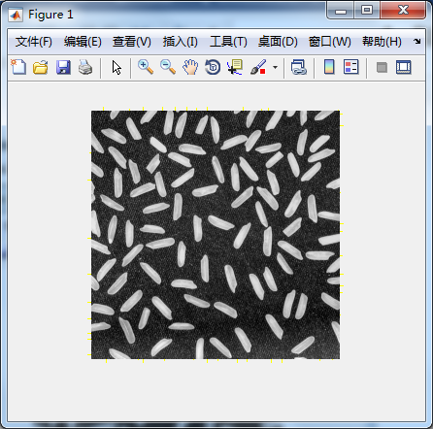

The original image:

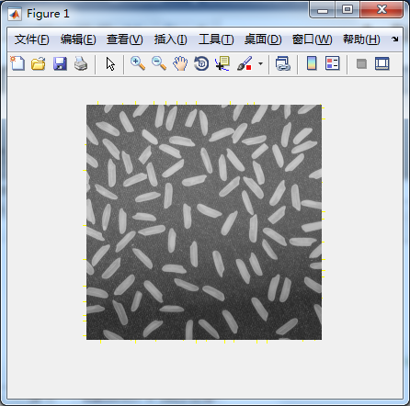

M=N=13.

I notice that the length of a rice is about 10 pixels, and the height of a rice is about 20 pixels. I choose the size of sub block which is smaller than a rice, but there always has background image in sub block. When I choose the min values of the sub images, I can always get the grey level of background points. Then I can use these points to calculate regression equation of background image. And I choose M=N=13 so that I can get as many as points from the background image, and I think that is accurate enough to calculate the regression equation with 6 coefficients.